SCHOOL OF COMPUTER SCIENCE AND ARTIFICIAL INTELLIGENCE |  |  |  |  | DEPARTMENT OF COMPUTER SCIENCE ENGINEERING
Program Name: M. Tech/MCA/MSC |  |  |  | Assignment Type: Lab |  |  | AcademicYear:2025-2026
Course Coordinator Name |  |  |  | Venkataramana Veeramsetty
Course Code |  |  |  | Course Title |  | AI Assisted Problem Solving Using Python
Year/Sem |  |  | II/I | Regulation |  | R24
Date and Day  of Assignment |  |  | Week5- Tuesday | Time(s)
Duration |  |  | 2 Hours | Applicable to  Batches
AssignmentNumber:12.3(Present assignment number) /24(Total number of assignments)
 | Q. No. | Question |  |  |  |  |  | Expected Time  to complete
 | 1 | Lab 12 – Algorithms with AI Assistance: Sorting, searching, and optimizing algorithms  Lab Objectives  - To implement classical algorithms (sorting, searching) with the help of AI tools.  - To analyze AI suggestions for efficiency and correctness.  - To explore AI-assisted optimizations of existing algorithms.  - To compare naive vs. optimized approaches generated by AI.  Learning Outcomes  After completing this lab, students will be able to:  • Implement sorting and searching algorithms using AI suggestions.  • Compare AI-generated algorithm variants in terms of readability and efficiency.  • Use AI to optimize brute-force algorithms into more efficient ones.  • Analyze algorithm complexity (time and space) with AI explanations.  • Critically reflect on correctness, clarity, and maintainability of AI-generated algorithms.  Task Description #1 – Linear Search implementation  Task: Write python code for linear_search () function to search a value in a list and extract its index.  Prompt: Write a linear_search( ) function to search for elements in the list and extract the indexes By taking the input elements of the list by the user. Take the list inputs from the user.  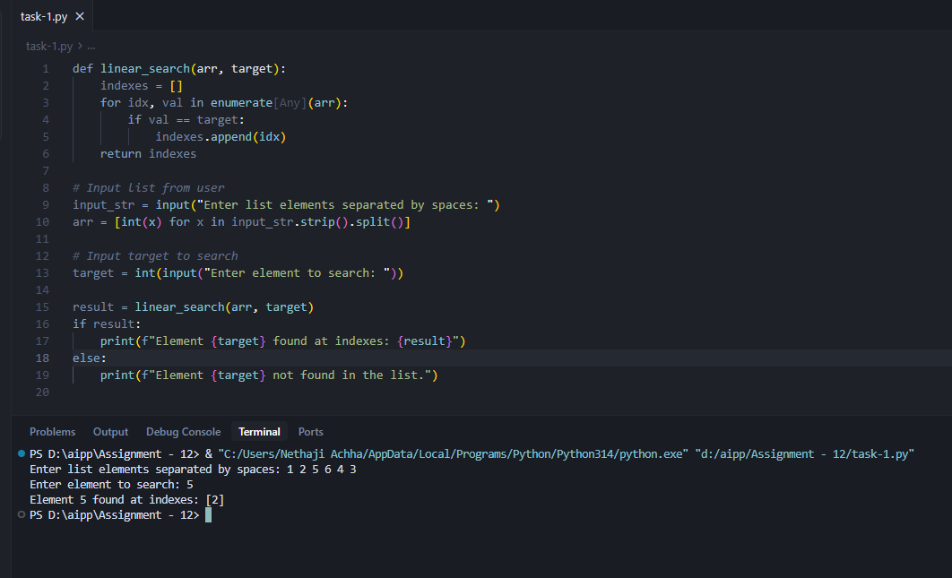  Task Description #2 – Sorting Algorithms  Task: Ask AI to implement Bubble Sort and check sorted output  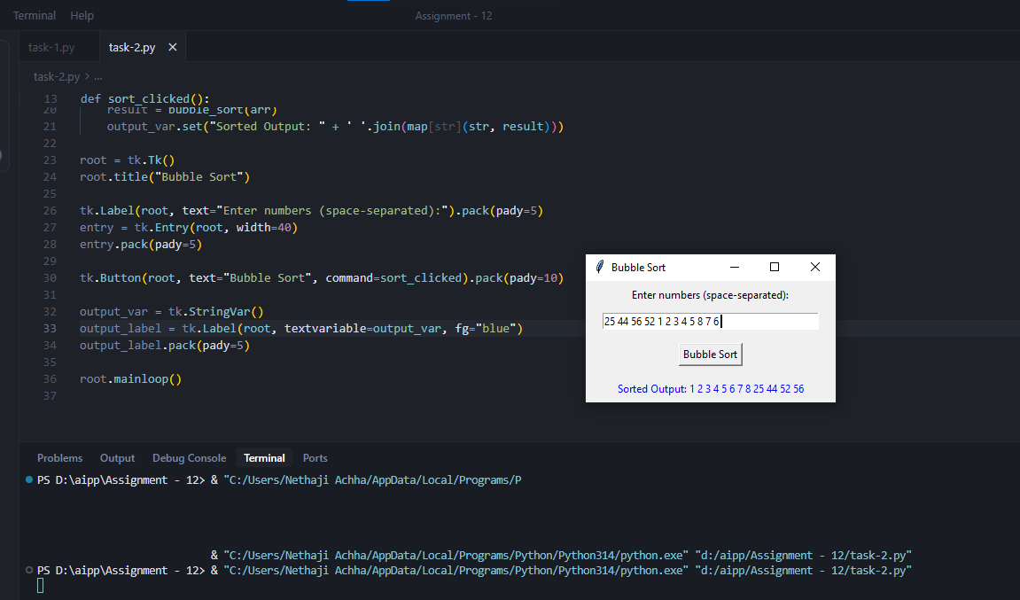  Task Description #3 – Optimization  Task: Write python code to solve below case study using linear optimization    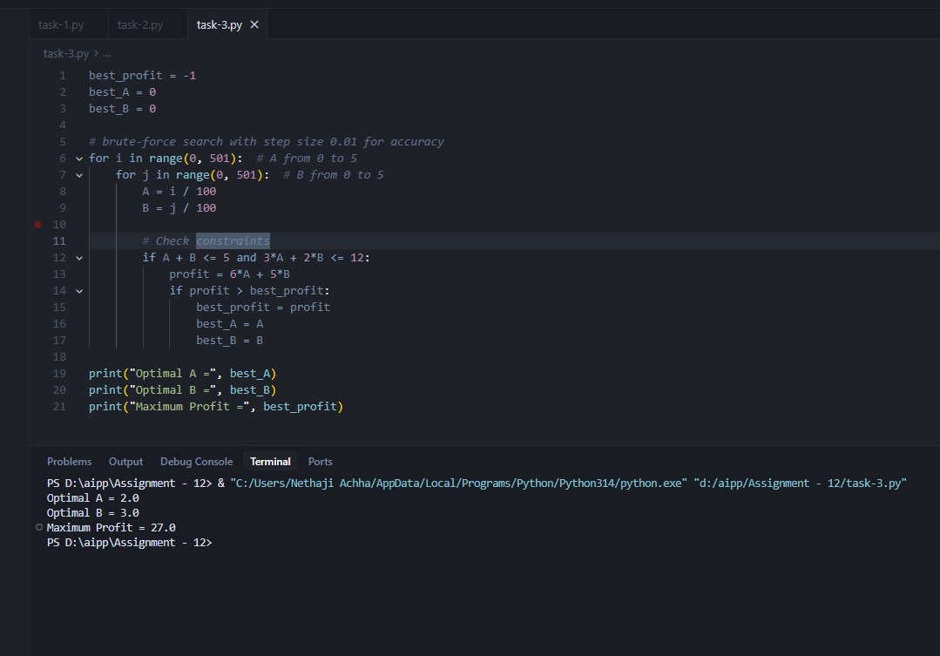  Task Description #4 – Gradient Descent Optimization  Task: Write python code to find value of x at which the function f(x)=2X³+4x+5 will be minimum  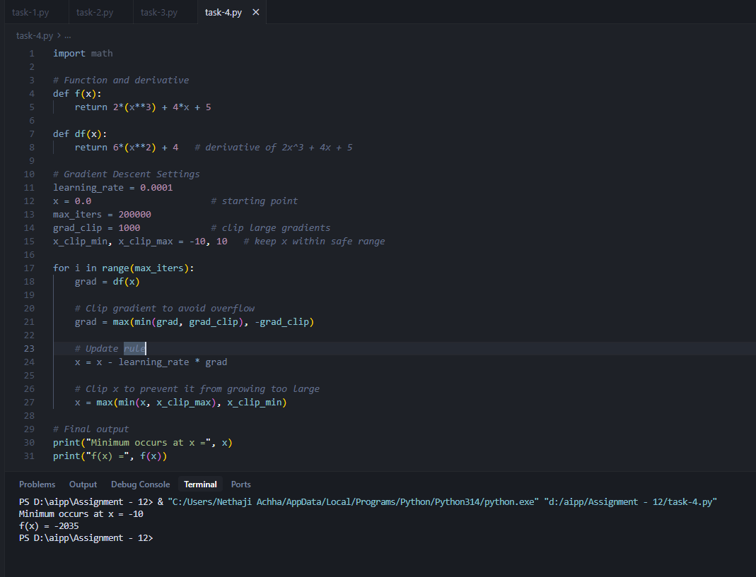s |  |  |  |  |  | Week5- Tuesday

